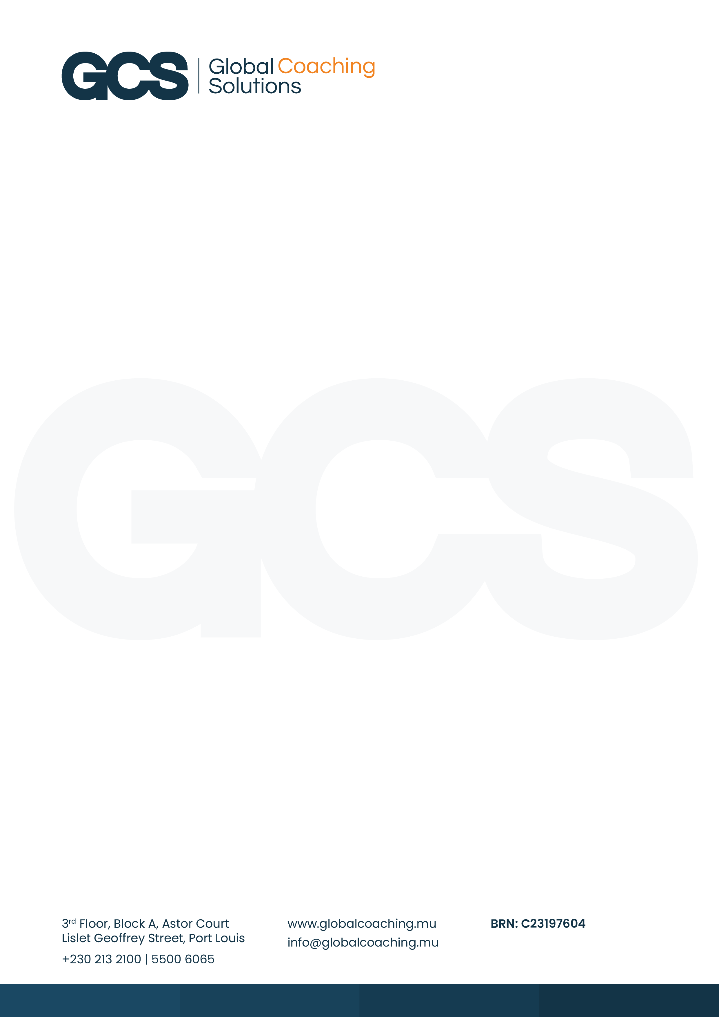

Version 1
Issued: Jan 2026

STUDENT HANDBOOK

ASSOCIATION OF CHARTERED CERTIFIED ACCOUNTANTS

(ACCA) QUALIFICATION

Table of Contents
Message from the Founder & Managing Director 1
1. About GCS 3
2. About ACCA 3
3. ACCA Programme Structure 3
4. ACCA Registration and Minimum Entry 3
Graduate-Entry Route 4
5. Fees and Financial Information 4
GCS Tuition Fees 4
ACCA Exam and Registration Fees 5
6. Academic Team – ACCA lecturers at GCS 5
7. Timetables and Delivery 6
8. Learning Materials 6
Access to ACCA Learning Resources 6
9. Assessment and Progression 7
Mock Examination 7
10. Revision and Support 8
11. Student Conduct and Responsibilities 8
12. Facilities and Safety 8
Student Identity Cards 9
13. Policies and Procedures 9
14. Career Development 9
15. ACCA Rules and Regulations 9
16. Refund Policy 10
ACCA fees 10
GCS Course fees 10
17. Student complaints procedure 11
Internal Complaints – GCS 11
External Complaints – ACCA 11
18. Course Enrolment 12
19. GCS Contact details 13
20. ACCA Contact Information 13

Message from the Founder & Managing Director

Dear Students,

Welcome to Global Coaching Solutions (GCS), where your journey towards becoming a Chartered Certified Accountant takes shape. As an ACCA Approved Learning Partner, we are proud to offer structured, high-quality tuition and academic support that reflect the exacting standards of ACCA.

Whether you are new to ACCA or continuing your studies, we are delighted that you have chosen GCS to support your qualification journey. We are pleased to present our latest suite of courses, expert tutors, and study options, tailored to help you thrive both academically and professionally.

At GCS, we are committed to maintaining the highest standards of professional training and student support. Our teaching approach and academic planning are carefully aligned with ACCA’s performance objectives and the evolving needs of the finance and accounting sector.

This handbook has been designed as a comprehensive resource to guide you through your programme, outlining key policies, procedures, and expectations to help ensure a smooth and successful learning experience.

We invite you to make full use of the guidance, resources, and expertise available to you throughout your time with us.

Wishing you every success in your studies and future career.

Sooruj Mannick, FCCA
Founder & Managing Director

STUDENT HANDBOOK

About GCS
Established in 2023, Global Coaching Solutions (GCS) is dedicated to advancing professional development through targeted corporate training and internationally recognised qualifications, including the Association of Chartered Certified Accountants (ACCA) programme. GCS aims to enhance employability, drive professional growth, and improve workplace productivity through structured learning pathways that meet industry and academic standards.

Our mission
To provide a dynamic and enriching learning experience that empowers individuals to excel in their personal and professional lives.

Our Vision
To become a prominent source of innovative education, cultivating confident individuals equipped with the skills and knowledge to thrive in an ever-evolving world.

About ACCA
The Association of Chartered Certified Accountants (ACCA) is a globally recognised professional accountancy body headquartered in the United Kingdom. The ACCA Qualification is designed to equip students with the technical knowledge, ethical grounding, and strategic insight required to excel in the fields of accounting, auditing, taxation, and financial management. With members and students in over 180 countries, ACCA offers a truly international qualification that is respected by employers across sectors.

ACCA Programme Structure
The ACCA Qualification comprises three examination levels: Applied Knowledge, Applied Skills, and Strategic Professional. Each level builds upon the previous, developing both technical competence and professional judgement. Students must also complete the Ethics and Professional Skills Module (EPSM), which enhances ethical decision-making and communication skills, and fulfil the Practical Experience Requirement (PER), which involves 36 months of relevant work experience and the achievement of nine performance objectives. This integrated structure ensures that ACCA graduates are both academically prepared and professionally experienced.

ACCA Registration and Minimum Entry
Prospective students must register directly with ACCA via the myACCA portal. Entry requirements vary depending on prior academic qualifications, and exemptions may be granted for relevant prior learning. GCS provides guidance throughout the registration process, including support with exemption applications and documentation. It is the student’s responsibility to maintain an active ACCA registration and ensure timely payment of annual subscription fees.

Entry requirements: 2 passes at GCE A Level / Higher School Certificate [grades A-E]
PLUS passes at GCE O Level / School Certificate [grades A-C or 1-6] (in 5 separate subjects including English and Maths)

Eligibility for entry onto the ACCA Qualification may be verified by consulting the official ACCA minimum entrance requirements published at: www.accaglobal.com/gb/en/qualifications/glance/acca/minimum-entrance.html

Graduate-Entry Route
Applicants holding a relevant degree from a recognised institution may be eligible to register directly at a higher level of the ACCA Qualification. ACCA assesses each qualification individually and may award exemptions from specific papers based on subject relevance and academic content.

Foundations in Accountancy (FIA) Route
Students who do not meet the standard academic entry requirements may begin their studies via the Foundations in Accountancy route. This pathway provides access to the ACCA Diploma in Accounting and Business and is suitable for individuals aged 18 or over. Upon successful completion, students may transfer to the ACCA Qualification.

Entry requirements: Passes at GCE O Level / School Certificate [grades A-C or 1-6] (in 5 separate subjects including English and Maths)

Exemptions
Exemptions from ACCA papers may be granted based on prior academic or professional qualifications.
- Exemptions are available for papers at the Applied Knowledge and Applied Skills levels only.
- No exemptions are awarded for Strategic Professional papers.
- Students must submit certified documentation and may use ACCA’s Exemption Enquiry Tool to check eligibility.

All exemption decisions are made solely by ACCA. GCS provides advisory support but does not determine exemption outcomes.

Fees and Financial Information
To undertake the ACCA Qualification at GCS, students are required to pay fees in two distinct categories: tuition fees payable to GCS and registration/examination fees payable directly to ACCA.

GCS Tuition Fees
Tuition fees are payable to GCS and are calculated based on the modules enrolled, and any additional learning services provided. Tuition fees typically cover the following:
- Registration and administrative charges
- Delivery of ACCA modules by approved tutors
- Access to approved learning materials and revision kits
- Scheduled mock examinations session/s
- Academic support
- Kaplan Study Text and Exam kits

All tuition fees are communicated in advance and must be paid prior to the start of the programme.

Please note:
Once enrolment is confirmed, tuition fees are strictly non-refundable, regardless of attendance or completion status, except in exceptional circumstances as determined by management on a case-by-case basis.

ACCA Exam and Registration Fees
These fees are payable directly to ACCA via the student’s myACCA account and are necessary to maintain registered student status and sit ACCA examinations.

Fee Type | Amount (GBP) | Notes
Initial Registration Fee | £45 | One-time fee upon joining ACCA
Annual Subscription Fee 2026 | £140 | Payable each year to maintain active student status
Re-registration Fee | £45 | Applicable if registration lapses
Ethics and Professional Skills Module (EPSM) | £81 | Mandatory module for Strategic Professional progression
Applied Knowledge Exam | ~£125 per paper | Includes BT, MA, FA
Applied Skills Exam | ~£155 per paper | Includes LW, PM, TX, FR, AA, FM
Strategic Professional Exam | ~£202–£274 per paper | Includes SBL, SBR and options

Students are advised to check the latest figures on the ACCA Fees and Charges page.

All ACCA-related payments are non-refundable beyond the standard cancellation window. Students must ensure timely registration and payment to avoid late fees or disqualification.

Academic Team – ACCA lecturers at GCS
At GCS, our academic team comprises professionally qualified and experienced tutors who are dedicated to delivering high-quality tuition across all levels of the ACCA Qualification. Each tutor brings subject-specific expertise, industry insight, and a learner-centred approach to teaching, ensuring that students receive both academic rigour and practical relevance in their studies.

Tutors at GCS are selected based on their professional credentials, teaching experience, and familiarity with ACCA syllabus requirements.

Each tutor is responsible for:
- Delivering structured tuition aligned with the ACCA syllabus and examination standards
- Facilitating revision sessions and mock exam reviews
- Providing academic support and feedback on student performance
- Advising students on exam technique, time management, and progression planning

Students are encouraged to engage proactively with their tutors, seek clarification when needed, and participate actively in classroom discussions and revision activities.

A final list of tutors, including their subject allocations and contact details, will be provided during induction and published on the institutional website. Any changes to tutor assigned will be communicated in advance by the admin team.

Timetables and Delivery
At the commencement of each academic term, GCS issues a detailed timetable outlining module delivery dates, lecturer allocations, room assignments, and study modes. Timetables are designed to accommodate both full-time and part-time students. Students are expected to adhere to the published schedule and notify the institution promptly in the event of unavoidable absences. Timetables are subject to change, and any amendments will be communicated in advance.

Learning Materials
GCS provides students with a comprehensive suite of learning resources, including ACCA-approved Kaplan study texts, revision kits, and supplementary notes prepared by our academic team.

Access to ACCA Learning Resources
Students will also gain access to the ACCA Practice Platform and Study Hub, which offer interactive tools for exam preparation. Materials are distributed at the start of each module and are integral to both classroom instruction and independent study. Students are encouraged to utilise these resources fully to enhance their understanding and exam readiness.

To complement your tuition and support your exam preparation, we strongly encourage all students to take advantage of the comprehensive study resources provided by ACCA. These include:
- Detailed syllabus and study guides for each paper
- Past examination papers and Examiner Reports
- A variety of supplementary materials tailored to each exam subject

These resources are designed to deepen your understanding, reinforce key concepts, and enhance your exam readiness. They are especially valuable when used alongside structured tuition and guided revision.

To explore and access these materials, please visit the official ACCA student portal: http://www.accaglobal.com/uk/en/student.html.

Assessment and Progression
Assessment at GCS is both formative and summative. Internal assessments include mock examinations, coursework, and class tests designed to monitor progress and reinforce learning. Feedback is provided to support academic development and exam preparation.

External ACCA examinations are held quarterly in March, June, September, and December. Students must register for these exams via the ACCA website and adhere to published deadlines. Progression through the qualification is contingent upon successful completion of each level and compliance with ACCA’s examination regulations.

GCS specifically prepares students for the June and December exam sittings to ensure focused support and readiness for these key assessment periods.

Mock Examination
All mock examinations submitted by students will be reviewed, marked, and returned within seven to ten working days of the submission date.
This ensures timely feedback, allowing students to identify areas for improvement and refine their exam strategy ahead of final assessments.

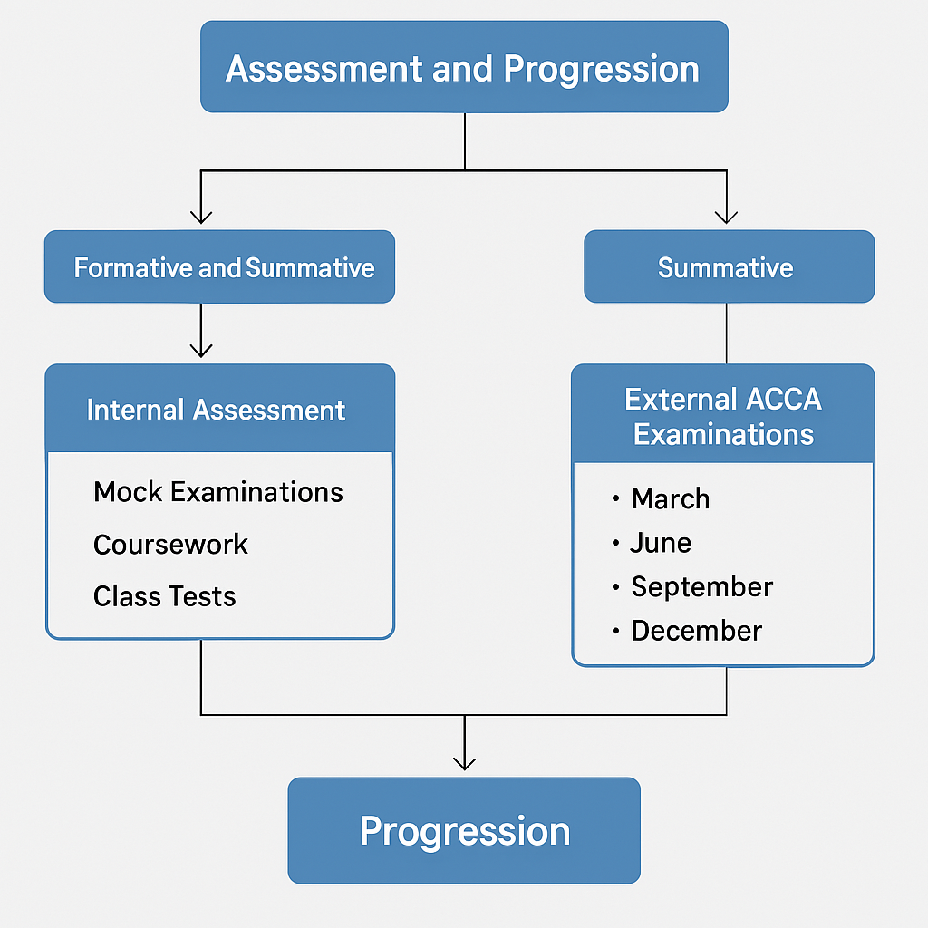

Revision and Support
GCS offers structured revision sessions prior to each ACCA exam sitting. These sessions focus on exam technique, time management, and question practice using past papers. Students benefit from targeted support designed to address individual learning needs and reinforce key concepts. Academic mentoring is available throughout the term, and students are encouraged to seek guidance from tutors and support staff. Additional revision sessions will be provided to students, ensuring they are well prepared for the examination.

Student Conduct and Responsibilities
Students at GCS are expected to uphold the highest standards of professional conduct, in line with ACCA’s Code of Ethics and Conduct. This includes demonstrating integrity, respect, and accountability in all academic and interpersonal interactions. Punctuality, regular attendance, and active participation are essential. Students must dress appropriately, behave respectfully, and engage fully with the learning process. Breaches of conduct may result in disciplinary action in accordance with institutional policy.

Facilities and Safety
GCS provides access to well-equipped classrooms, study areas, and common rooms. Health and safety briefings are conducted during induction, and students are informed of fire exits, assembly points, and emergency procedures. The institution maintains a safe and supportive learning environment, and students are encouraged to report any hazards or incidents promptly. Wellbeing support is available, particularly during examination periods, to help students manage stress and maintain balance.

Student Identity Cards
Full‑time students will be eligible to apply for Student Identity Cards (Bus Pass). The SIC will be issued by the NLTA. Students must ensure that their address is verified and provide a passport‑sized photograph together with the required application fee. The photograph must measure not less than approximately 4.5 cm by 3.5 cm and be taken against a plain white background.

Policies and Procedures
GCS operates a range of policies designed to ensure fairness, transparency, and academic integrity. These include procedures for complaints and appeals, misconduct, and data protection policies. Students are expected to familiarise themselves with these policies, which are available via the institutional website. Adherence to these procedures is essential for maintaining the integrity of the learning environment.

Career Development
GCS is committed to supporting students in their professional development. Services include guidance on completing the Practical Experience Requirement (PER), CV writing workshops, interview preparation, and access to the ACCA Careers Portal. Networking events and employer engagement sessions will be organised to connect students with industry professionals. Students are encouraged to maintain a professional portfolio and seek relevant work experience throughout their studies.

ACCA Rules and Regulations
All students must comply with ACCA’s published rules and regulations, which govern examination conduct, ethical standards, and progression requirements. These include the ACCA Rulebook, examination terms and conditions, and disciplinary procedures. Students are expected to familiarise themselves with these documents and adhere to them throughout their studies. Non-compliance may result in sanctions, including disqualification from examinations or removal from the ACCA register.

The ACCA’s rules and regulations may be accessed via the official ACCA Rulebook, available at www.accaglobal.com/gb/en/about-us/regulation/rulebook.html.

Refund Policy

ACCA fees
ACCA permits examination refunds only if cancellation is made before the standard entry deadline and within the 14-day cooling-off period. Requests must be submitted via the MyACCA portal and are processed using the original payment method.

You can refer to ACCA’s official refund and cancellation terms in their Exam Entry Terms and Conditions, available at: www.accaglobal.com/sg/en/student/exam-entry-and-administration/enter-an-exam/exam-entry-terms-and-conditions.html.

GCS Course fees
GCS kindly advises that tuition fees are non-refundable once enrolment has been confirmed. This policy applies to all programmes and modes of study offered. Students are therefore encouraged to review all course details and associated financial commitments carefully prior to registration to ensure full confidence in their academic decisions.

Students enrolled on an ACCA qualification at GCS are required to settle tuition fees in full upon registration or as per payment plan agreed by the Management.

However, GCS permits the transfer of paid tuition fees under the following conditions:
- Fees may be transferred to a future intake date, to an alternative ACCA paper offered by GCS.
- Transfer requests must be submitted within either:
  - 30 calendar days from the original date of payment, or
  - 14 calendar days following the official release of ACCA examination results.

Transfer requests made beyond this period may be accepted at the discretion of GCS, but may be subject to a proportional deduction from the original payment. In such cases, a minimum retention fee of Rs 1,000 per paper will apply to cover administrative costs.

In the unlikely event that GCS is unable to deliver a scheduled course, the full tuition fee will be refunded in accordance with institutional policy. Refunds of GCS course fees, outside of these provisions, will be considered on a case‑by‑case basis and are subject to approval by the Management.

Student complaints procedure
At GCS, we are committed to fostering a fair, transparent, and supportive learning environment. Students are encouraged to raise any concerns they may have through the procedure outlined below.

Internal Complaints – GCS
1. Informal: Resolution Students are encouraged to raise any concern informally, in the first instance, with the relevant member of staff (e.g. tutor or administrative team). Many issues may be resolved promptly and effectively through open dialogue.

2. Formal Submission: If the concern remains unresolved or if the matter warrants formal attention, students may submit a written complaint (as per the Complaint/Appeal form) addressed to the Manager. The complaint should clearly outline the issue and include any relevant supporting evidence. A complaints form may be used and submitted in person or via email asha@globalcoaching.mu.

3. Review and Response: All formal complaints will be reviewed by a senior member of staff who has not been directly involved in the matter. A written response will normally be issued within ten working days, and all complaints will be handled confidentially and in accordance with GCS’s internal policies.

4. Escalation: If a student is dissatisfied with the formal response, they may escalate the complaint to the Managing Director for final review. Appeals must be submitted within ten working days of receiving the outcome.

GCS ensures that no student will be disadvantaged or penalised for lodging a legitimate concern. A Complaint Register will be maintained to record and monitor all formal complaints.

External Complaints – ACCA
If the complaint relates specifically to ACCA matters, such as conduct, examination procedures, or the behaviour of an ACCA member, students may submit a formal complaint directly to ACCA. However, students are first expected to exhaust the internal complaints procedure of their institution.

If the issue is not resolved satisfactorily through the institutional and ACCA processes, students may escalate their concern to the appropriate regulatory body. Full details, including procedural guidance and access to downloadable forms, are available via ACCA’s official complaints page: Making a Complaint About an ACCA Member Further information on unresolved complaints can be found at: Unhappy With Our Service https://www.accaglobal.com/gb/en/footertoolbar/contact-us/connect/unhappy.html.

Course Enrolment

Students must complete their registration prior to commencing the programme. This may be done either through the registration form or via the link available on the GCS website (www.globalcoaching.mu).

At the time of registration, students are required to submit the necessary documents to info@globalcoaching.mu and provide proof of payment of course fees to finance@globalcoaching.mu.

Once enrolment has been confirmed, the Administrative Department will secure the student’s place and advise on the next steps.

Once a student is initially registered on the ACCA platform, all payments relating to ACCA exams, registration fees, and other associated charges must be made directly via the myACCA platform.

GCS Contact details
Key contact information:

Administrative Department  - Email: info@globalcoaching.mu  - Phone: +230 213 2100  - Mobile: +230 5500 6065 | Finance Department  - Email: finance@globalcoaching.mu  - Phone: +230 213 2100  - Mobile: +230 5500 6065
Training Manager  - Email: asha@globalcoaching.mu  - Phone: +230 213 2100  - Mobile: +230 5500 6065 | Head of Academic Affairs  - Email: m.atchanah@globalcoaching.mu  - Phone: +230 213 2100  - Mobile: +230 5500 6065

ACCA Contact Information
To assist with general queries relating to ACCA and its qualification pathways, students seeking detailed information or clarification on specific matters are advised to contact ACCA directly via the channels below:

Postal Address ACCA Connect 110 Queen Street Glasgow G1 3BX United Kingdom
Telephone Enquiries UK/International: +44 (0)141 582 2000 /
Mauritius (Local Support): 401 0220
Email info@accaglobal.com / student@accaglobal.com
Official Website www.accaglobal.com

For comprehensive guidance on entry requirements, exam registration, exemptions, and other formal processes, students are encouraged to consult the ACCA website accaglobal.com or reach out directly through the contact options provided.

